***OOPS LAB***

***Reg no: -22108190***

***Name: -Muneeb***

**Program-1**

#include<iostream>

using namespace std;

class add

{

private:

int inum1,inum2,inum3;

public:

void input(int ivar1,int ivar2)

{

inum1=ivar1;

inum2=ivar2;

}

void sum()

{

inum3=inum1+inum2;

}

void display()

{

cout<<"sum of two variables are:"<<inum3;

}

};

int main()

{

add A;

int x,y;

cout<<"enter the values of x and y:";

cin>>x>>y;

A.input(x,y);

A.sum();

A.display();

}

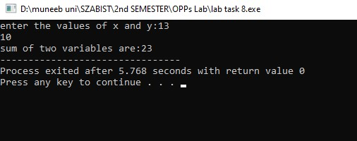

**Program-2**

#include <iostream>

using namespace std;

class MyRecord

{

private:

double oopMarks;

double attendance;

public:

MyRecord()

{

oopMarks = 0.0;

attendance = 0.0;

}

void inputMarks()

{

cout << "Enter OOP Marks (out of 100): ";

cin >> oopMarks;

}

void inputAttendance()

{

cout << "Enter Attendance (out of 15): ";

cin >> attendance;

}

double percentage()

{

return (oopMarks / 100) * 100;

}

double attendanceCalculator()

{

return (attendance / 15) * 100;

}

void display()

{

cout << "OOP Marks: " << oopMarks << "/100" << endl;

cout << "Attendance: " << attendance << "/15" << endl;

cout << "Percentage: " << percentage() << "%" << endl;

cout << "Attendance Percentage: " << attendanceCalculator() << "%" << endl;

}

};

int main()

{

MyRecord record;

record.inputMarks();

record.inputAttendance();

record.display();

return 0;

}

